**Lab Experiment – 1**

**Aim**: Write a program to make a simple calculator.

**Code**:

*/\*\**

*\**

*\* @author 2162014*

*\*/*

import java.util.Scanner;

public class Calculator {

public double Operations(char o, double r, double n1, double n2) {

*// conditions to perform arithmetic operations*

switch (o) {

case '+' -> {

System.out.println("\nAddition: " + n1 + " + " + n2);

r = n1 + n2;

break;

}

case '-' -> {

System.out.println("\nSubtraction: " + n1 + " - " + n2);

r = n1 - n2;

break;

}

case '*' -> {

System.out.println("\nMultiplication: " + n1 + " * " + n2);

r = n1 * n2;

break;

}

case '/' -> {

System.out.println("\nDivision: " + n1 + " / " + n2);

r = n1 / n2;

break;

}

default -> {

System.out.println("\nInvalid input!\n");

break;

}

}

return r;

}

public static void main(String[] args) {

Scanner scn = new Scanner(System.in);

Calculator obj = new Calculator();

System.out.print("\n-+-+-+-+Calculator-+-+-+-+\n");

*// Menu*

System.out.print("\nOperations:\n1. Addition\n2. Subtraction\n3. Multiplication\n4. Division\n");

*// get numbers from user*

System.out.print("\nEnter first number: ");

double num1 = scn.nextDouble();

System.out.print("\nEnter second number: ");

double num2 = scn.nextDouble();

*// get operation from user*

System.out.print("\nChoose operations(+,-,*,/): ");

char op = scn.next().charAt(0);

double result = 0, ans = obj.Operations(op, result, num1, num2);

*// display output to user*

System.out.printf("\nResult: %.2f \n", ans);

System.out.print("\n");

}

}

**Output**:

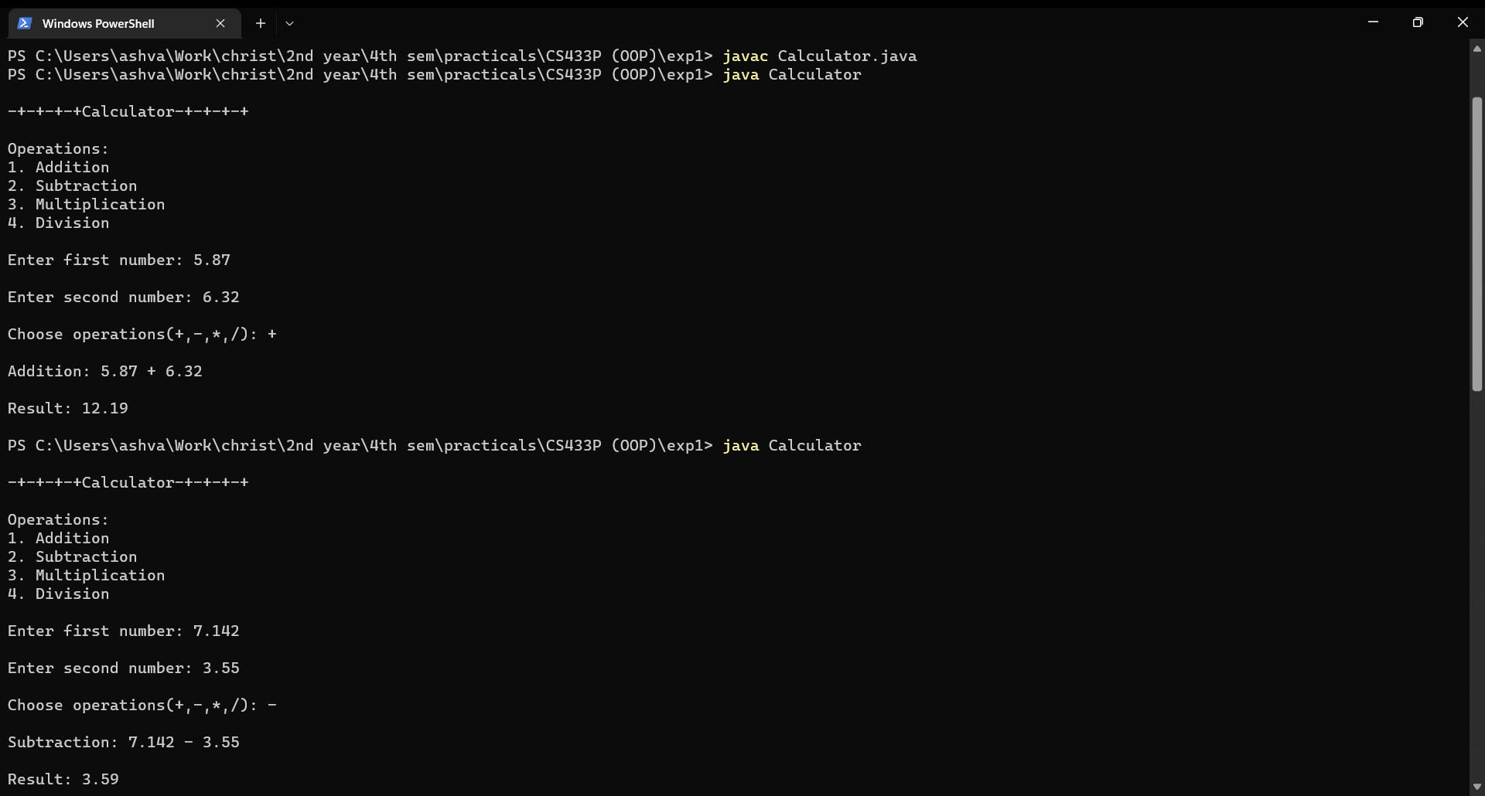

**Fig. 1** – Output for addition and subtraction

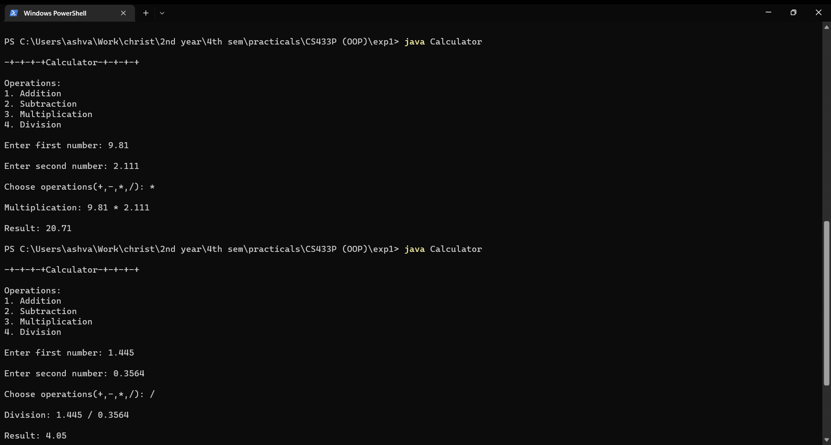

**Fig. 2** – Output for multiplication and division